**Pycharm Debugger**

Debugging python code:-

1. Lets check debugger functionality by doing simple BMI calculator program.

BMI (Body-Mass index) = weight (in Kg)/ height (in m2)

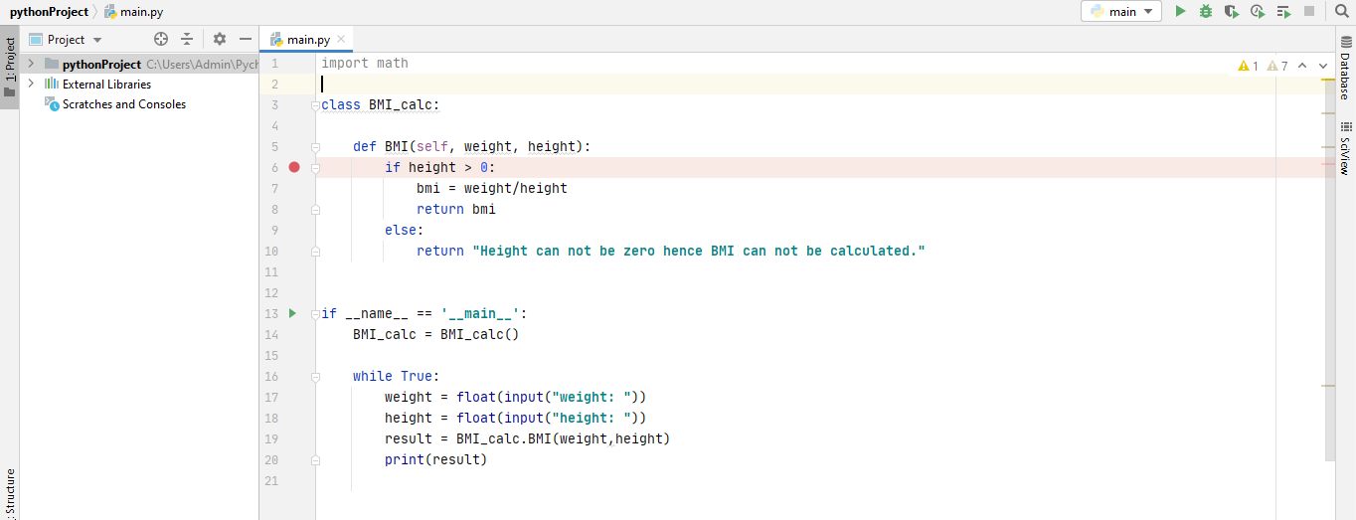

As per the above image, there is the main clause where execution will begin .let you enter the desired values of the variables height and weight, and then enter the method BMI.

1. For debugging perspective, we can place breakpoint in the code just by clicking the gutter next to the line we want our application to be suspend as shown in image below:-

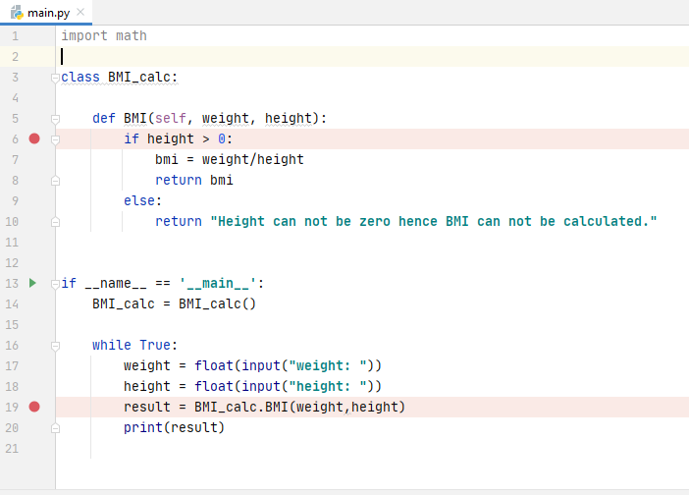

1. After adding breakpoints, we can now process further for debugging. PyCharm gives an option for starting the debugger session in several ways.

Click Run in the gutter, and then select the command Debug 'main' in the popup menu that opens:

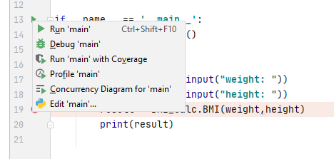

1. The debugger starts and shows the Console tab of the Debug tool window, and lets you enter the desired values for height and weight:

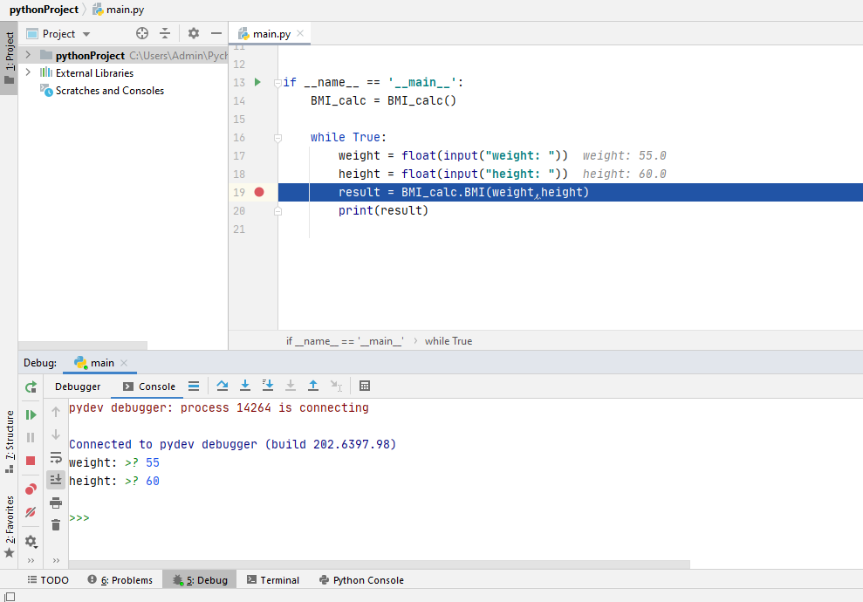

1. In the **Debug Console**, you can enter the Python commands as well

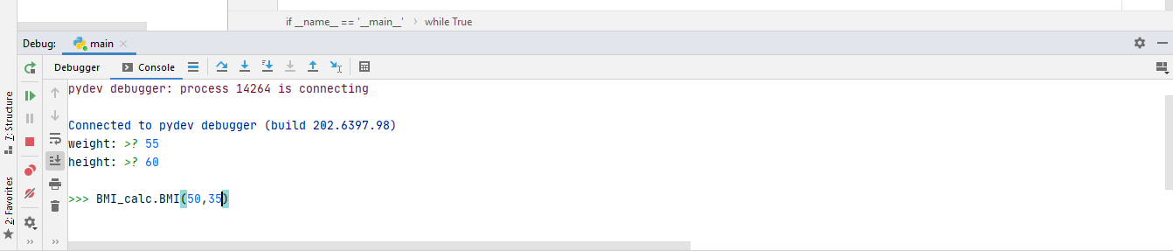

1. The debugger suspends the program at the first breakpoint which we have set up in our application. It means that the line with that breakpoint is not yet executed. The line becomes blue:

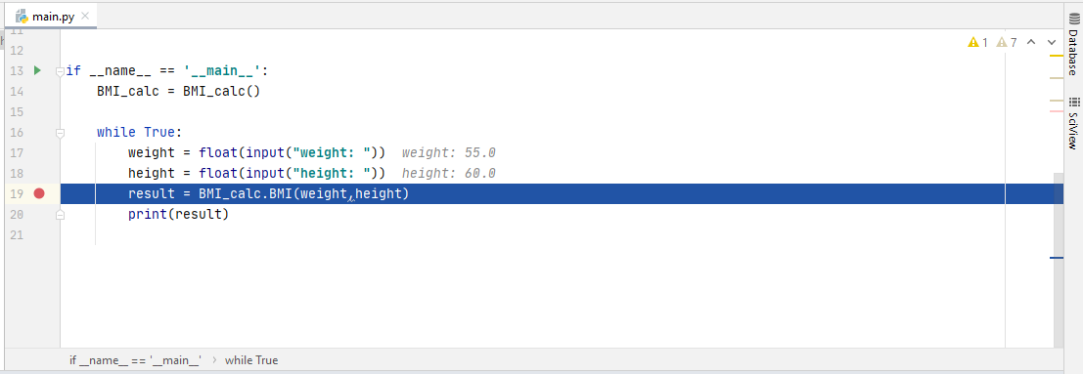

1. On the stepping toolbar of the Debugger tab , click the button Resume, to move to the next breakpoint.

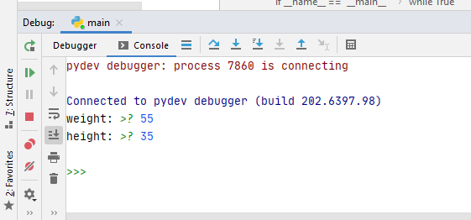

Inline debugging:-

In the editor, you see the grey text next to the lines of code:

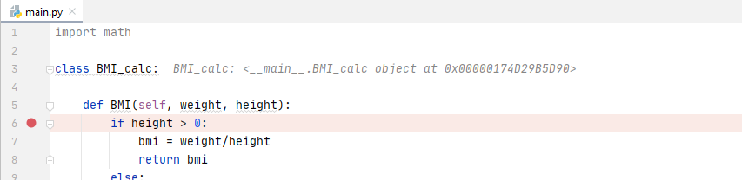

This is the result of the so-called inline debugging . The first lines show the address of the main object and the values of the variables height and weight you've entered.

So, When you've clicked the buttonResume, and now see that the blue marker moves to the next line with the breakpoint.

If you use the stepping toolbar buttons , you'll move to the next line. For example, click the buttonStep Over. Since the inline debugging is enabled, the values of the variables show in italic in the editor.

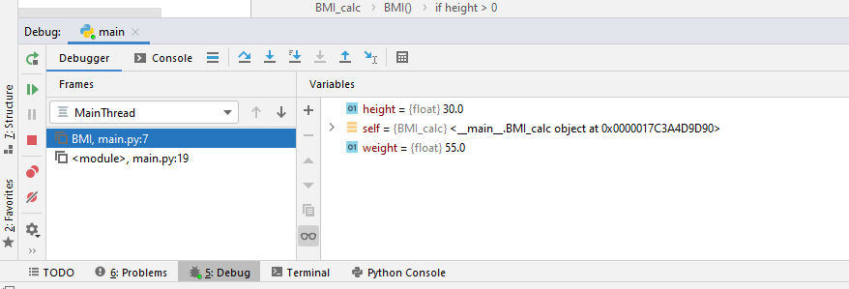

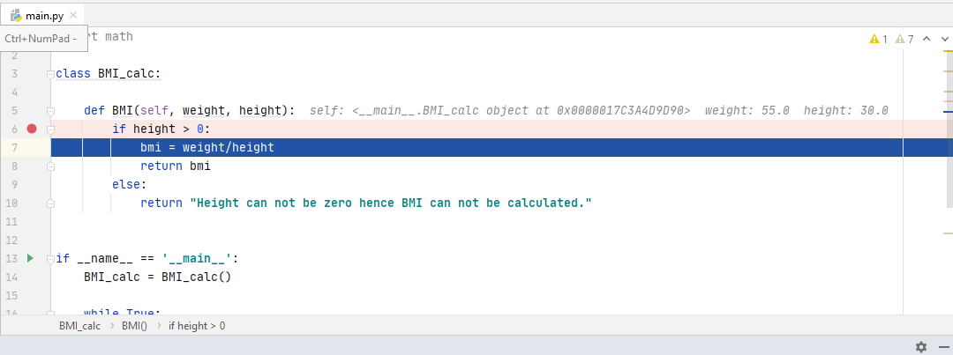

Finally, you can evaluate any expression at any time. For example, if you want to see the value of the variable, click the button Evaluate expression, and then in the dialog that opens, click Evaluate:

